Deep Learning Based Visibility Analysis in Food and Cosmetic Advertisement
Sharwari Mondhe, Kartik Gorde, Anuradha Karule, Shlok Patel, Ved Misar
Department of Information Technology, Sipna College of Engineering and Technology, Amravati
sharwari774@gmail.com
kartikgorde04@gmail.com anuradhakarule0@gmail.comshlokpatel0550@gmail.com
vedmisar30@gmail.com

Abstract— The rising trend of visual advertising through digital channels has created a need for automated systems which provide objective evaluation of product visibility and brand visibility. Existing methods for advertisement evaluation research rely on manual rules and user input which hinders their ability to produce consistent results at scale. This paper presents a comprehensive deep learning–based framework for advertisement visibility analysis in the food and cosmetic domains. The proposed system uses YOLOv8 for precise product identification and a visual saliency–based attention model to predict human visual attention and PaddleOCR for the identification and assessment of text elements which include brand names and promotional material. The system uses object localization combined with attention maps to calculate visibility metrics which include an attention-based visibility score and a distraction rate. The evaluation process uses two custom datasets which contain more than 10,000 cosmetic advertisement images and 7,000 food advertisement images. The experimental results show strong performance with mAP@0.5 values reaching 0.908 for cosmetic products and 0.842 for food products. The results demonstrate that the automated visibility assessment framework successfully assesses visibility and maintains performance at larger scales.

Keywords— YOLOv8, Visual Saliency, Advertisement Visibility, Object Detection, OCR, Deep Learning
- INTRODUCTION
Digital advertising has expanded rapidly across online platforms and social media, establishing visual content as the primary channel for brand communication and product promotion. The success of advertising campaigns in competitive markets depends on the effective presentation of product and brand elements and their ability to attract consumer attention. Accurate analysis of product visibility is therefore essential for advertisers, designers, and regulatory bodies responsible for evaluating advertisement standards and compliance requirements [1], [11].

Traditional approaches for evaluating advertisement performance rely on manual visual inspection, expert judgment, and consumer-based studies such as surveys and eye-tracking experiments. Although these methods provide valuable insights, they are time-consuming, costly, and inherently subjective, which limits their scalability and suitability for large-scale and real-time digital advertising analysis [2], [4]. Furthermore, variations in human visual perception lead to inconsistent assessments of product visibility and visual emphasis across different observers.

Recent advances in deep learning and computer vision have enabled automated systems to analyze visual content with high accuracy. Convolutional Neural Networks (CNNs) have demonstrated strong performance in object detection, image classification, and logo recognition, making them effective for identifying products and brand elements in advertisement images [3], [5], [15]. In parallel, visual saliency models have been developed to estimate human visual attention by predicting regions likely to attract viewer focus [4], [5]. Optical Character Recognition (OCR) techniques further allow extraction and analysis of textual elements such as brand names and promotional messages, which play a critical role in advertisement effectiveness [6].
- Related Work

The current research studies automatic advertisement evaluation systems which use three separate functions to analyze visual content through object detection and visual saliency systems and text extraction methods. The real-time capabilities of Object detection frameworks which include YOLO enable users to track products and logos in commercial images and videos [1] [2] yet these systems fail to recognize which elements draw human visual attention. Visual saliency models aim to predict viewer focus, with early feature-based methods [3] and recent deep learning–based approaches demonstrating improved attention estimation accuracy [4], while Wang et al. proposed a multi-scale saliency framework specifically for video advertisements [5]. Saliency-based methods operate without connection to object detection systems because they lack specific metrics which measure product visibility. Text recognition techniques using OCR have also been applied to extract brand names and promotional content from advertisements [6], but are often treated as standalone processes. Some recent works attempt to combine multiple visual cues for advertisement evaluation [7], [8]; however, they do not provide a unified quantitative formulation that jointly considers product localization, visual attention, and text readability. The proposed method unifies product detection through YOLOv8 and saliency-based attention measurement and OCR text readability assessment into one visibility scoring system which allows researchers to analyze food and cosmetic marketing materials in an objective and scalable manner.

  - Deep Learning for Visual Saliency and Attention Prediction

The research investigates human visual attention through deep learning visual saliency prediction which detects key visual areas in both images and videos. The traditional hand-crafted feature-based saliency models which use hand-crafted features to create saliency maps lack the ability to capture vital semantic information. This information is essential for understanding how people pay attention to intricate visual material found in advertisements.

The authors present a convolutional neural network (CNN) framework which learns hierarchical feature representations from data to solve existing limitations. The model captures both low-level visual cues, including color, contrast, and texture, and high-level semantic information which includes objects and regions of interest. The method produces better saliency maps because it performs better in visually complex environments. The experimental evaluation on standard saliency benchmark datasets demonstrates that the system achieves better precision, recall, and F-measure results when compared to traditional methods. The research establishes a solid base for visibility assessment in food and cosmetic advertisements, although it does not specifically focus on advertising analysis.

  - Deep Learning–Based Saliency Assessment for Product Placement in Video Advertisements

Wang et al. (2024) developed a deep learning saliency assessment model to test product placement effectiveness in video advertisements. Their research solves the problems that arise when using manual assessment methods and standard computer vision techniques which cannot properly track complex patterns of attention in moving advertisement material.

The proposed architecture combines multi-scale feature extraction with temporal modeling to study detailed visual elements and product visibility patterns that last throughout video frames. The model uses attention mechanisms to identify the areas which viewers will notice most, because these regions have the highest visual impact. The model was tested on a dataset which included 10,000 video sequences from different product categories that ranged from food to beverages. The experimental results show that the system outperforms current saliency detection methods because it achieves high detection accuracy while processing data in real time. The ablation studies demonstrate that multi-scale and temporal features play a critical role in achieving successful visibility assessment results.

  - Object Detection for Advertisement Analysis

Researchers have studied how to combine real-time object detection systems which use YOLO (You Only Look Once) with visual saliency systems for advertising research. YOLO enables users to detect multiple objects in images and video frames with rapid speed and high accuracy which allows them to identify products and logos and all other elements that attract viewer attention. The combination of YOLO object detection with saliency prediction techniques enables researchers to achieve better visibility results for advertisements because they can measure both product location and product visibility. The method provides benefits for dynamic video advertisements which require fast object detection to achieve between-frame detection. Studies demonstrate that YOLO-enhanced saliency models can complement CNN-based attention frameworks by providing explicit object localization which strengthens the automated analysis of product placement strategies.

  - Visual Saliency Prediction Using Deep Learning

This study investigates CNN-based visual saliency prediction through data-based learning of hierarchical feature representations. The proposed approach uses low-level visual cues together with high-level semantic information to successfully detect regions that attract attention in complex scenes. The method performs exceptionally well on benchmark datasets which demonstrate that deep learning architectures effectively model human attention in real-world visual scenarios. The study results provide essential insights for assessing visually complex advertisement images which display multiple competing visual elements.

  - Saliency-Based Product Placement Analysis

Wang et al. (2024) conducted research about saliency-based evaluation methods which assess product placement effectiveness in video commercials. Their method shows how attention mechanisms and temporal consistency work together to establish product visibility for assessment purposes. The system achieves better results through multi-scale feature extraction which enables detection of prominent product areas while temporal integration maintains visibility assessment throughout different video segments.

The results demonstrate that advertisement visibility assessment through saliency-based frameworks enables automatic evaluation which produces valuable information about product and brand placement methods.
- Methodology
The developed method creates a unified deep learning system which automates the process of assessing advertisement visibility for food and cosmetic advertisements. The system starts with advertisement preprocessing which leads to two different systems that measure product visibility and visual attention together with text understanding capabilities. The design evolves from standard post-launch assessment methods to introduce new diagnostic tools that test advertisement visual effectiveness through design stage evaluations before consumer outreach..

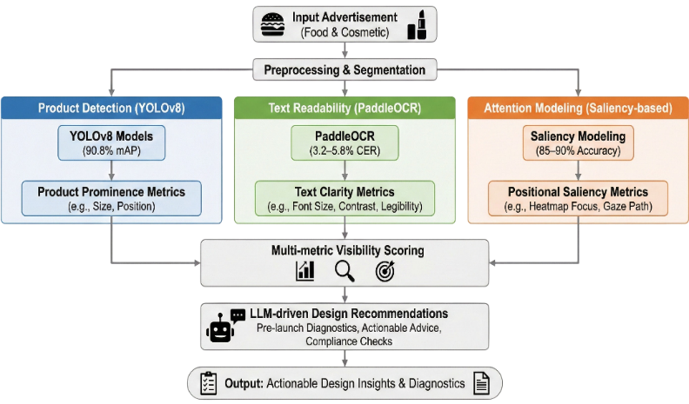

Fig. 1. Deep Learning Framework for Advertisement Visibility Assessment
The system measures advertisement visibility through three different dimensions which combine to create three separate measurement components, as shown in Fig. 1. The system uses three deep learning components to model its three dimensions which include product detection with YOLOv8 and attention modeling through a saliency-based model and text readability analysis via Paddle OCR. The system converts module outputs into interpretable metrics which create a multi-metric visibility score that enables the objective assessment of advertisement layouts. The product detection system establishes a link between basic visual elements and advanced marketing results because it matches detected products with customer attention areas and text comprehension zones, which leads to practical design solutions and regulatory validation.

- Product Detection and Prominence Analysis (YOLOv8)

The first step of the advertisement visibility assessment framework requires product detection and prominence analysis as its fundamental component. This module uses a YOLOv8-based object detection system to automatically detect and show the locations of products which appear in food and cosmetic advertisements according to the demonstration in Figure 2. The main purpose of this stage is to complete product visual information extraction which will enable future research on attention patterns and text relationship analysis.

The detection method used by YOLOv8 results in accurate detection results which the system can process in real-time. Advertisement images often contain visually cluttered backgrounds which combine different objects and display various lighting conditions especially in digital and social media campaigns. The YOLOv8 architecture effectively addresses these challenges by learning robust spatial and semantic representations which allow it to detect products such as cosmetic containers and creams and bottles and burgers and pizzas with high precision. The detection model produces output which includes bounding boxes and class labels along with confidence scores that match each detected product instance.
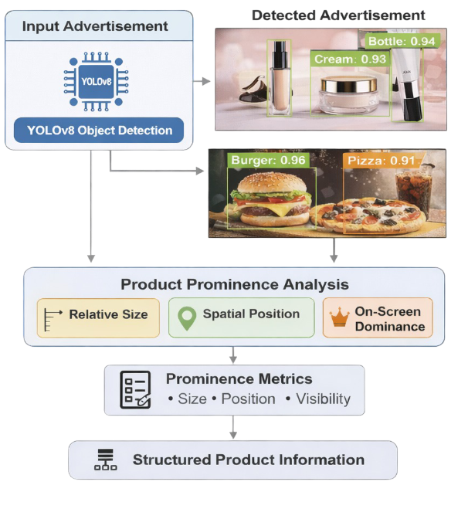

Fig. 2. Product Detection using YOLOv8

After detection, the system conducts product prominence assessment on the detected localized bounding boxes which appear in Fig 2. The analysis measures the visual dominance of each detected product which exists within the advertisement layout. The system uses spatial and geometric features to measure prominence which includes the product's size in relation to the image area and its position within the frame and its visual presence against other detected objects. The system uses these attributes to decide if a product receives strong visual emphasis or if its visibility gets reduced through nearby elements.

The first metric stage creates metrics which supply complete structured information about product visibility. The structured output functions as essential data which third modules use to establish links between user attention points and areas that contain readable text. The system achieves complete visibility assessment through its detection system which operates with both product presence and product visibility.

- Saliency Model Analysis

The attention modeling module assesses visual focus in advertisement images through its saliency-based approach which it demonstrates in Fig. 3. The process begins by feeding the input advertisement into a visual saliency model which analyzes low-level and high-level visual features to generate a pixel-wise attention heatmap. The system extracts key cues through color contrast and texture variation and edge density and semantic distinctiveness to identify regions which people will likely observe. The saliency map shows which parts of the advertisement attract most viewer attention and it establishes basic information about how viewers distribute their focus throughout the picture.
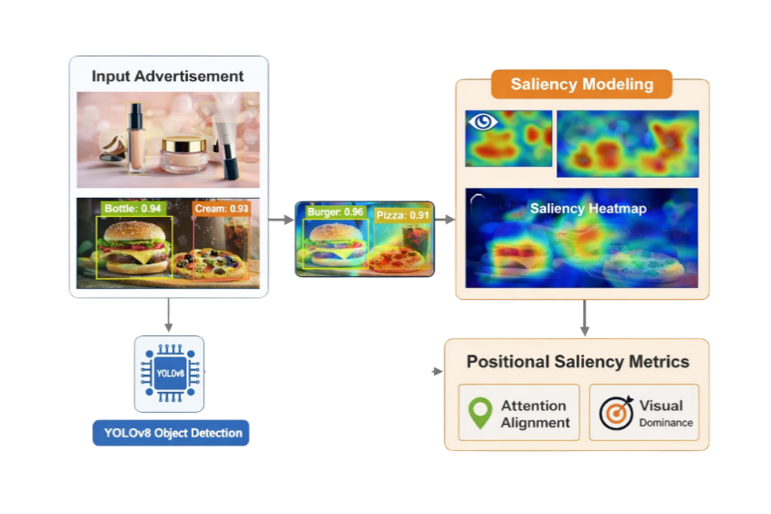
Fig. 3. Architecture of the visual saliency based attention modeling

The process begins when the saliency map creation is completed which leads to its alignment with the advertisement's identified product areas. This technique enables researchers to evaluate whether viewers focus their attention on specific product locations within the advertisement. The module uses attention map intensity values to compare product locations which enables it to identify products that either appear in the scene or occupy areas that attract most attention. The ability to distinguish between different product displays shows how product placement affects consumer recognition of products.

The insights derived from this attention-aware analysis are then used to compute metrics that quantify the visibility of each product in the advertisement. The metrics in this system measure product presence together with product visual prominence which allows the system to connect basic object detection results with human observation results. The system uses attention-based metrics to improve its visibility scoring system which gives more precise results for measuring advertisement effectiveness. The approach creates advertisements which provide information to viewers while achieving maximum engagement and attention from them.
- Attention–Based Visibility Score Computation

The core objective of the proposed methodology is to quantify how visually prominent a detected product is within an advertisement frame. This is achieved by mathematically combining object localization information obtained from the YOLO object detection model with visual attention information derived from a saliency-based attention model. The integration of these two modules enables the system to evaluate not only whether a product is present in the frame, but also whether it attracts human visual attention.
For each detected product instance, YOLO provides a bounding box defined by its spatial coordinates $B=(x_{1},y_{1},x_{2},y_{2})$, which represents the exact region where the product appears in the image. In parallel, the saliency model generates a pixel-wise heatmap $S$, where each pixel intensity $S_{i,j}∈[0,255]$indicates the relative visual attention assigned to that location. Higher intensity values correspond to regions that are more likely to be observed by a human viewer.
To combine these two outputs, a Region of Interest (ROI)–based averaging strategy is employed. The saliency heatmap is spatially restricted to the bounding box region corresponding to the detected product. The attention score for a single frame is then computed as the mean saliency intensity within this region, normalized to a percentage scale. Mathematically, this is expressed as:

$\text{Attention Score}=\left(\frac{1}{N}\sum_{(i,j)∈B}{S_{i,j}}\right)×\frac{100}{255}$ (1)
where $N$ represents the total number of pixels inside the bounding box. This formulation ensures that the attention score is independent of bounding box size and provides a normalized measure of visual attention focused on the product. A higher attention score indicates that the product lies within a highly salient region of the frame, while a lower score suggests that the product is visually overshadowed by other elements

- Visibility Score Aggregation

While the attention score measures visual prominence at the frame level, advertisement visibility is inherently a temporal concept that spans multiple frames in a video. To capture the overall visibility of a product across an entire advertisement, the proposed system aggregates frame-level attention scores into a global visibility metric.
Let $A_{t}$denote the attention score computed for a detected product at frame $t$, and let $N$be the total number of frames in which the product is detected with sufficient confidence. The final visibility score is computed as the arithmetic mean of all attention scores:

$\text{Visibility Score}=\frac{1}{N}\sum_{t=1}^{N}{A_{t}}$ (2)
This visibility score represents the expected visual attention received by the product over the duration of the advertisement. By averaging across frames, the metric accounts for both short-term visual emphasis and sustained prominence. Products that consistently appear in salient regions achieve higher visibility scores, whereas products that are frequently present but rarely attract attention receive lower scores.

- Distraction Rate Estimation

In addition to measuring visibility, the methodology also evaluates cases where a product is physically present in the frame but fails to attract visual attention. This phenomenon is captured through the distraction rate metric, which quantifies the conflict between object presence and viewer attention.
A frame is classified as distracted if the detected product satisfies two conditions: (1) the YOLO detection confidence exceeds a predefined threshold, ensuring reliable object presence, and (2) the corresponding attention score falls below a predefined attention threshold, indicating low saliency in the product region. The distraction rate is computed as the ratio of distracted frames to the total number of frames in which the product is detected:

$\text{Distraction Rate}=\left(\frac{\text{Number of Distracted Frames}}{\text{Total Frames with Detection}}\right)×100$ (3)
This metric provides insight into situations where competing visual elements such as faces, lighting effects, or background objects divert attention away from the product. A high distraction rate suggests ineffective product placement or visual competition within the advertisement layout.

- Paddle OCR Module

Fig. 4. presents the text readability and semantic extraction module based on Optical Character Recognition (OCR). The module detects and extracts textual elements from advertisement images which include brand names and prices and promotional messages through its ability to identify and recognize text regions present in visual content.
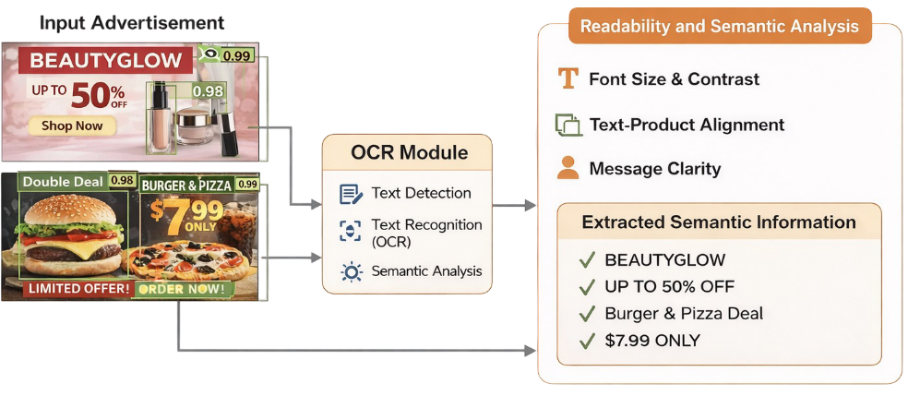
Fig. 4. Working of OCR module

The system analyzes extracted text to assess its readability through three factors which include font size and background contrast and text position. The attributes help assess two things about the text which are its visibility to viewers and its ability to match the visual presentation of the product.
The evaluation process assesses the semantic connection between readable text and the advertised product and message. The module evaluates text clarity and meaning to assess advertisements through their visual presence and their ability to communicate text content.

- Large Language Model

The diagram shows how Large Language Model (LLM) technology functions as the core element of the design recommendation system within the complete advertisement visibility assessment system. The system contains an intelligent decision-making component which processes results produced by three deep learning components: product detection and text readability evaluation and attention modeling. The LLM system uses its multi-dimensional visibility metrics to connect basic numerical data points with advanced design recommendations which humans can understand, thus providing designers and advertisers valuable insights. The LLM receives structured visibility metrics which show product visibility and text comprehension and eye movement patterns at the input stage. The system obtains data which includes product dimensions and placement and text clarity assessment results and saliency heatmap detection and eye tracking results. The system provides both numerical and categorical information and diagnostic signals which identify design flaws that lead to poor visibility and low attention capture and cluttered layouts. The LLM uses this extensive contextual data to build a complete understanding of how well the advertisement visual elements work.

The LLM uses its reasoning capabilities to incorporate best practices from specific fields and platform requirements and advertising regulations. The model combines its acquired language skills with established compliance standards and industry practices to determine whether advertisements meet branding requirements and readability standards and ethical and legal restrictions. The ability to detect compliance violations and design problems before product launch proves beneficial because it enables companies to save expenses which would result from making corrections after their products go live.

The LLM-driven module produces design recommendations which include both design solutions and detailed system evaluations. The results include three components which are pre-launch assessments and specific product improvement recommendations and compliance validation reports. The module uses its analytical results to produce understandable guidance which helps users make better decisions while ensuring that advertisements maintain both visual appeal and platform compliance with their intended meaning.

- Dataset Description

The cosmetic dataset contains more than 10,000 labeled images which showcase different types of cosmetic packaging that advertisers typically use. The collection includes bottles, jars, lipsticks, tubes, pumps, and generic cosmetic packaging. The dataset enables object detection training through its coverage of product size, shape, color, orientation, and background context variations.

The food dataset consists of approximately 7,000 annotated images which focus on commonly advertised food packaging formats that include packets and cans and bottles. The dataset provides various visual elements which show different branding designs and packaging materials and lighting setups.
The datasets are partitioned into three subsets which include training and validation and test sections to assist in developing the model and optimizing its hyperparameters and measuring its performance without bias. The model evaluation process requires assessment of the model using data that has not been presented to it before which enables an accurate measurement of its ability to generalize.
- Class Distribution and Annotation Statistics

The analysis of class distribution across different categories shows a clear distribution imbalance, which is especially evident in the cosmetic dataset. The Lipstick and Pump classes contain far more instances than the Jar and Generic Cosmetic classes. The classification imbalance demonstrates actual advertisement distribution patterns but it will cause model learning problems because it pushes the system to favor more common classes.

The annotation statistics show that most objects in the dataset are located close to the center of the image which indicates center-biased product-focused datasets. The spatial consistency of the data can enhance training convergence but it will restrict the system's ability to handle objects situated away from the center.

According to analysis of the bounding box sizes, most of the objects are inside the small and medium range while elongated bounding boxes are mostly found in vertically oriented packaging such as bottles and tubes. These statistics give an idea about the scale variation and aspect ratio distribution that are important factors for anchor-based object detection models.

- Data Annotation Format and Organization

The YOLO object detection format, in which each annotation contains a class label and normalized bounding box coordinates representing the object’s center position, width, and height. This format makes the real-time detection frameworks easy to train on. The datasets are organized following standardized directory structure that includes separate folders for images and labels within training, validation, and test splits. A dedicated data.yaml configuration file defined dataset paths, class names and total number of classes. This uniform organization makes it possible to work with YOLO-based pipelines and facilitates re-conducting of experiments system on Failure.
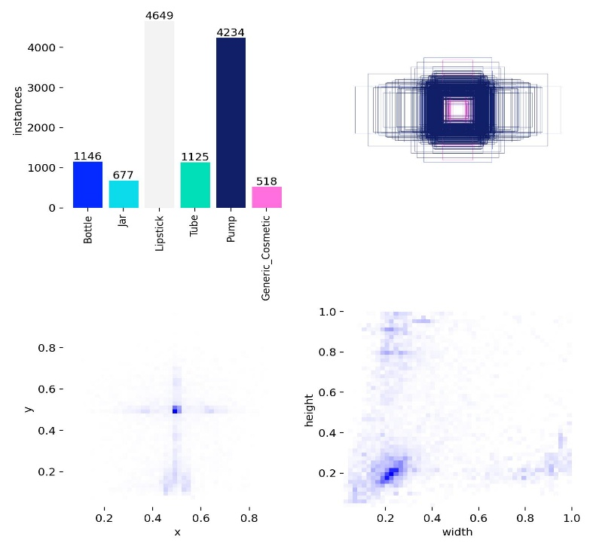
Fig. 5. Object Distribution and Spatial Statistics (Cosmetic)

This fig. 5. provides a comprehensive overview of the dataset composition and annotation characteristics used for training the object detection model.

The class distribution bar chart (top-left) shows the number of annotated instances per category. The dataset contains an imbalanced distribution because Lipstick class has 4649 instances and Pump class has 4234 instances which serve as the main classes of the dataset. The two classes Jar and Generic Cosmetic show a detection performance decrease because they only include 677 and 518 instances respectively.

The bounding box overlay visualization displays both spatial object alignment and their scaling differences through its top-right section. The central area shows dense object overlap because most objects in the dataset tend to be positioned at the center of images which reflects a common pattern seen in product-related photographs.

The bounding box center distribution heatmap (bottom-left) further confirms this trend, with the highest density concentrated near the normalized coordinates (0.5, 0.5). The results indicate that image positions remained mostly unchanged throughout the entire study.

The heatmap in the bottom-right corner shows how different object dimensions and shape proportions distribute across various size categories. The bounding boxes mainly cover small to medium size ranges while the elongated shapes match the dimensions of vertically used products which include bottles and tubes.

The Fig. 5. presents essential dataset features which include class imbalance and center-aligned object placement together with scale variability, which determines how model training and evaluation should be conducted.

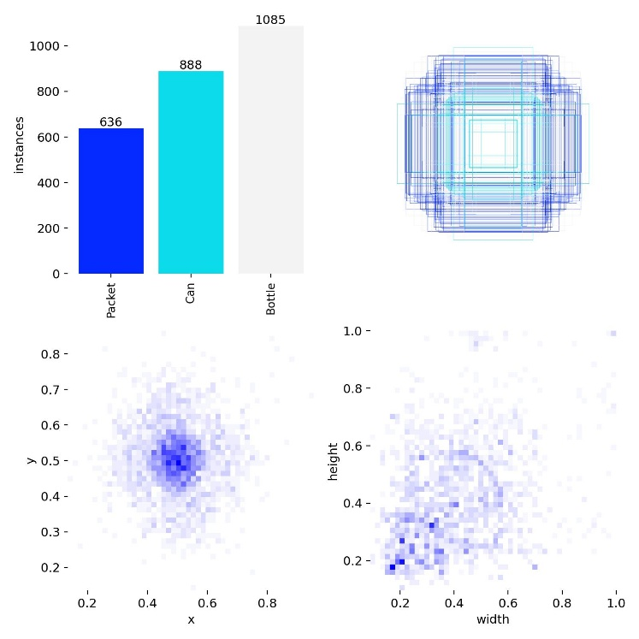

Fig. 6. Object Distribution and Spatial Statistics (Food)

Fig. 6. gives a comprehensive statistical summary of the object annotations used in this paper in the analysis of deep learning-based visibility analysis of food and cosmetic advertisements. The distribution of annotated objects by the classes indicates that bottles take the largest share, then cans, packets, which is not surprising as it is a standard advertising behavior to place more emphasis on bottled products to boost brand awareness. This distribution emphasizes the practical applicability of the dataset itself and its applicability to the context of real-life advertisements both in food and in cosmetic fields.

The overlay of the bounding box depicted in Fig. 6 shows that objects found are strongly concentrated spatially in the middle of the images. It indicates such central alignment, which implies that there are strategies of advertisement design techniques, which are meant to maximize product visibility and consumer attention. This tendency of space is also supported by the object centroid heatmap which shows high concentration of bounding box centers around the middle of the image. The central bias observed is in keeping with the known patterns of human visual attention and justifiable to integrate the saliency-based analysis to evaluate the visibility.

Moreover, the width height distribution of bounding boxes in Fig. 6. reveals that majority of objects that are annotated have moderate and fairly consistent spatial dimensions. This object sizing balance is such that the products are not either overwhelmed by the background images nor are too dominant in the frame therefore making it easy to detect them consistently. It is especially useful in the case of YOLOv8-based object detection, which has been shown to be quite consistent, allowing the successful anchoring matching and the enhanced accuracy of localization in a varied range of advertisement scenes.

In general, the statistical features as demonstrated in Fig. 6 justify the quality and appropriateness of the data to the proposed framework. The diversity of classes, the location of the objects to be processed centrally, and the constant spatial scaling offers a good basis behind the integration of the saliency prediction, OCR-based text analysis, and YOLOv8-powered object detection. These characteristics allow sound quantitative evaluation of product and brand visibility in food and cosmetic advertisements, which support the utility of the suggested deep learning-based visibility analysis.
- Results and Discussion
The experimental results and performance evaluation of the advertisement visibility analysis framework which we developed are presented in this section. The results are assessed based on three criteria which include object detection accuracy and saliency-based attention estimation and OCR-driven text evaluation.
- Results on Cosmetic Advertisements

The study evaluates cosmetic advertisements through two methods which include quantitative performance evaluation and class-wise analysis. The assessment process determines overall detection accuracy while showing how various cosmetic product categories affect performance results.

- Quantitative Performance Evaluation

The proposed model performance evaluation in this section uses standard object detection metrics which include precision, recall, F1-score, and mean Average Precision (mAP) for measurement. The detection accuracy assessment together with the detection robustness evaluation uses these metrics as comprehensive evaluation tools.

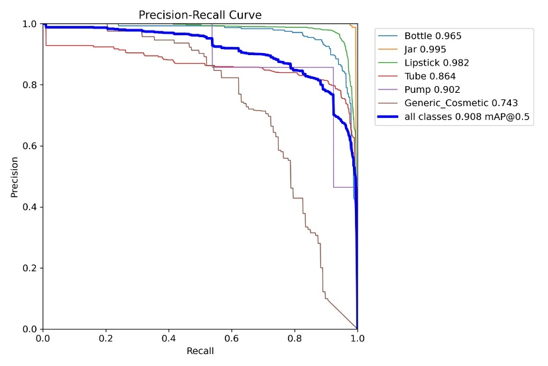
Fig. 7. Precision-Recall Curve

The Precision Recall (PR) curves display results for every cosmetic product class together with results for the complete model. The classes Jar and Lipstick together with Bottle reach average precision scores above 0.95, which demonstrates their ability to detect targets with high accuracy. Pump and Tube show moderate performance results, while Generic Cosmetic exhibits lower precision due to its increased visual diversity and limited training data. The model demonstrates excellent detection abilities because the bold curve shows overall class performance with an mAP@0.5 result of 0.908
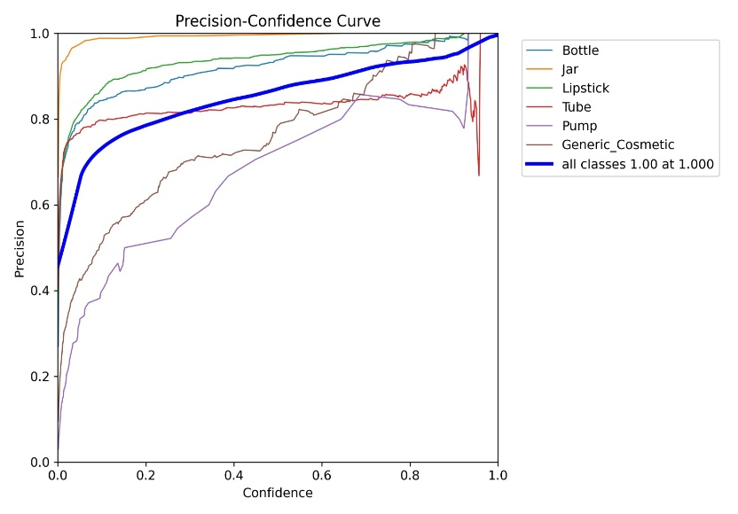Fig. 8. Precision-Confidence Curve

The detection precision for different classes changes with confidence threshold levels, as shown in fig. 8. The system shows improved detection accuracy when users raise confidence thresholds, which leads to decreased false positive errors. The Jar and Lipstick classes maintain their high precision rates even when users apply lower confidence thresholds because their class boundaries remain distinct. The two classes Generic Cosmetic and Pump demonstrate lower precision scores at low confidence thresholds because their visual patterns overlap. The bold curve indicates complete system performance across all classes, which achieves almost perfect precision at high confidence thresholds that help to choose the best threshold for accurate detection.
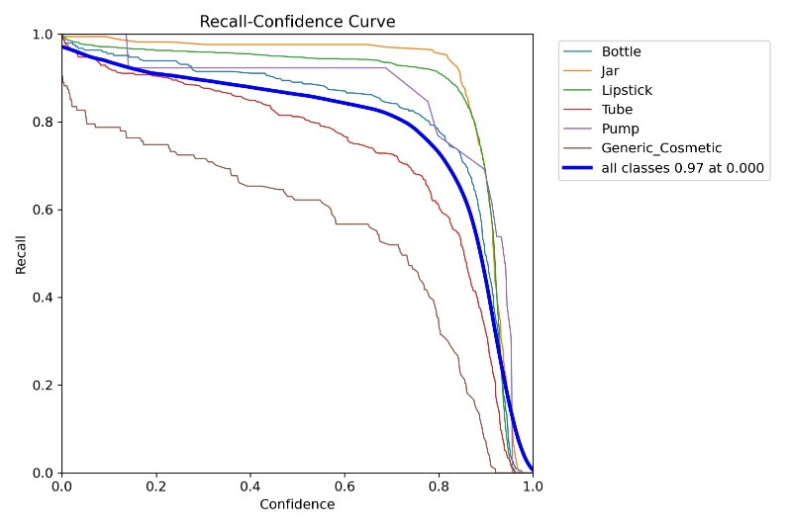
Fig. 9. Recall-Confidence Curve

Fig. 9. demonstrates how recall changes when confidence thresholds increase for every individual class. The model demonstrates excellent recall performance at low confidence thresholds because it successfully identifies most objects in the test. The recall rate decreases progressively as the threshold for confidence increases because the new thresholds prevent the system from detecting objects with low confidence. The Jar and Lipstick classes maintain high recall performance across multiple confidence ranges while Tube and Generic Cosmetic classes show decreasing performance because they have more class confusion and different visual characteristics. The bold curve represents the overall performance across all classes, highlighting the trade-off between recall and confidence selection.
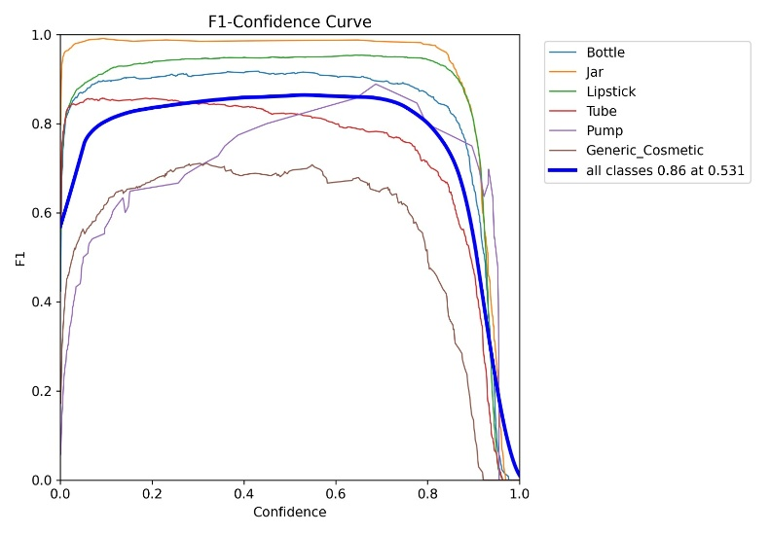
Fig. 10. F1 Confidence Curve

The F1 Confidence curve shows how the F1 score changes when different confidence levels are applied to each object category. At very low confidence thresholds, the F1 score decreases because false positive results occur in high volumes. The F1 score increases with rising confidence thresholds until it achieves its best performance through precise detection and accurate identification of actual instances. The F1 score starts to decline when the confidence threshold exceeds this optimum point because genuine detections start to get overlooked. The Jar and Lipstick classes demonstrate persistent high F1 scores through a broad range of confidence levels, which shows their ability to detect targets with strong accuracy. The Bottle test maintains stable results, although its highest performance level remains below the optimal mark. The Tube Pump and Generic Cosmetic categories show lower F1 scores because their products share more visual similarities and their products face more visual obstructions and their products show greater differences within the same category. The bold curve represents the average performance across all classes, achieving a maximum F1 score of 0.86 at a confidence threshold of approximately 0.53, which indicates the optimal operating point for the model.

- Class-wise Performance Analysis

This section presents a detailed analysis of the model’s performance across individual object classes. The detection accuracy between different cosmetic categories shows variation through our evaluation of class-wise precision and recall and F1-score metrics. The analysis allows us to identify classes that show consistent high detection accuracy and classes that remain difficult to identify because of visual similarity and shape variation and occlusion.
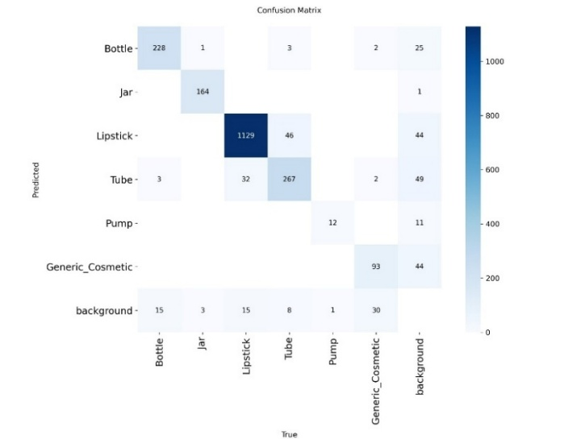
Fig. 11. Confusion Matrix

The proposed object detection model shows its performance through this confusion matrix which evaluates prediction accuracy for six cosmetic product categories and background. The predicted classes appear in the row structure while the ground-truth classes display their actual classes through column arrangement. The model shows correct predictions through its diagonal elements which display actual results while the off-diagonal elements show incorrect predictions. The model achieves strong performance for visually distinctive classes such as Lipstick (1129 correct detections) and Tube (267 correct detections), indicating high discriminative capability. Classification accuracy remains high for Bottle (228) and Jar (164) because these products maintain clear identification boundaries through their different characteristics. Generic Cosmetic shows higher misclassification rates because its visual features overlap with Lipstick and Tube which creates confusion between these two categories.
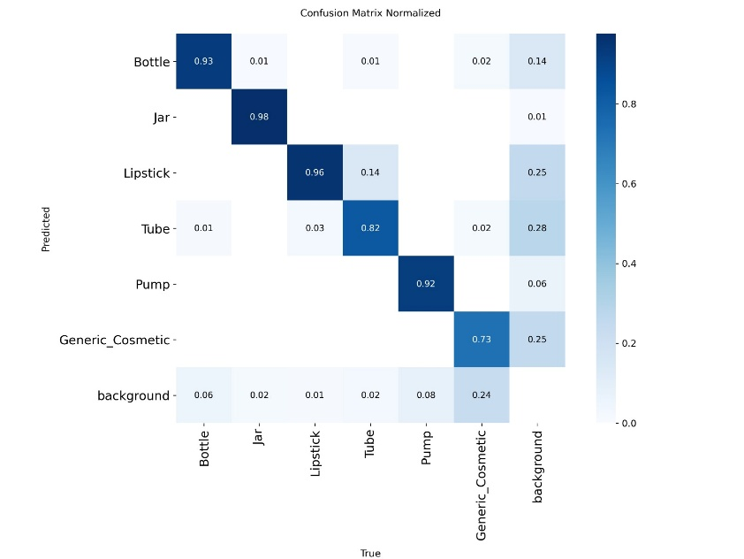
Fig. 12. Normalized Confusion Matrix

This fig. 12. presents the normalized confusion matrix, where each value represents the proportion of predictions relative to the true class distribution. Unlike the raw confusion matrix, normalization allows fair comparison across classes by accounting for class imbalance. High diagonal values indicate strong class-wise performance. The model achieves high recall for Jar (0.98), Lipstick (0.96), Bottle (0.93), and Pump (0.92), demonstrating reliable detection for visually distinctive categories. Tube (0.82) shows slightly lower performance due to visual similarity with lipstick-shaped products. The Generic Cosmetic class exhibits comparatively lower recall (0.73), with noticeable confusion toward Lipstick and Tube, reflecting its broad visual definition and limited training samples. Misclassification with the background class is also observed, particularly for smaller or less distinctive objects, indicating occasional false negatives.

Overall, the normalized matrix highlights consistent detection across most classes while identifying challenging categories that may benefit from additional data augmentation or refined feature learning.

- Result and Visual Analysis

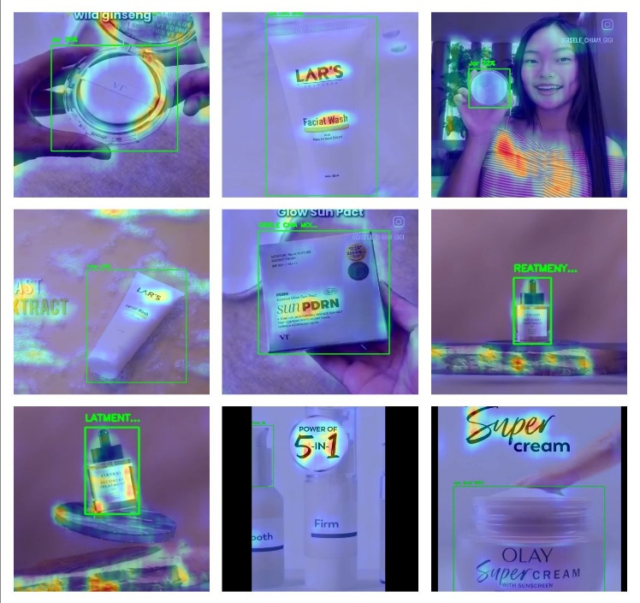

Fig. 13. Outputs for Cosmetic Advertisement

In Fig. 13. it provides a qualitative evaluation of how deep learning algorithms perform as regards the visibility of advertised cosmetic products. The figure depicts results that have to do with detecting and localizing cosmetic products like facial wash tubes displayed in YOLO-based object detection model with bounding boxes in green color, depicted with high confidence scores. Salient heatmaps that accompany demonstrate focused visual attention on all main branding elements, including logos, products names, and packaging designs, which are key issues affecting cosmetic marketing consumers’ perception. OCR is subsequently used for information retrieval from the detected regions enabling distinguishing text that represents brand names and product descriptors. Using saliency prediction combined with object detection model and OCR for visually appealing, rich advertisements like above examples ensures good visibility estimation despite difficulties related to appeal to reflectors on packaging or interference caused by similarity with other shades or blocking some part of objects display. Consequently these outcomes prove that the given approach is suitable for automated analysis of cosmetic commercials and determination of brand position on screen.

- Results on Food Advertisements

- Quantitative Performance Evaluation

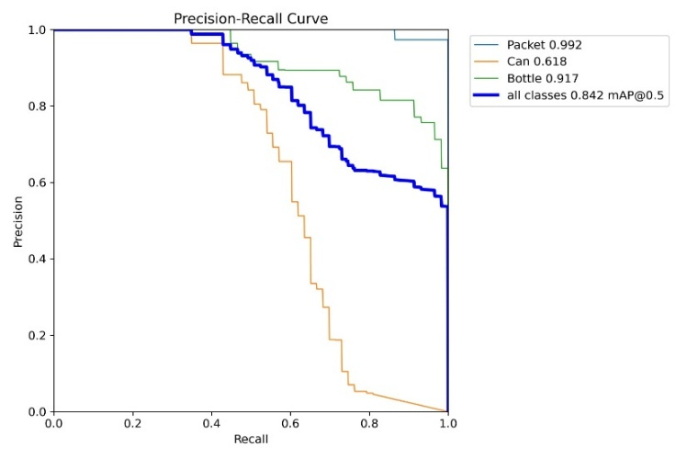
Fig. 14. Precision-Recall Curve
Fig. 14. shows the Precision-Recall curve of the proposed object detection model on Packet, Can, and Bottle categories as well as the general performance. Packet class has almost perfect detection with an average of 0.992 precision and a high precision at most of the recall range, which implies excellent visual specificity and dependable localization of advertisement scenes. The Bottle class also shows good performance at 0.917 AP which indicates a good performance of detecting the objects at different scales and positions. Contrary to that, the Can category has a relatively worse performance with an AP of 0.618 at which precision decreases more at higher recall rates because of visual similarities, reflections, and background clutter that is common when using real-world advertisements. The sum of all the classes results in the overall mAP 50 of 0.842, as depicted in Figure 6, which proves that the proposed framework is able to provide a balanced precision-recall trade-off and trustworthy multi-class detection in the analysis of food and cosmetic advertisements based on visibility analysis.
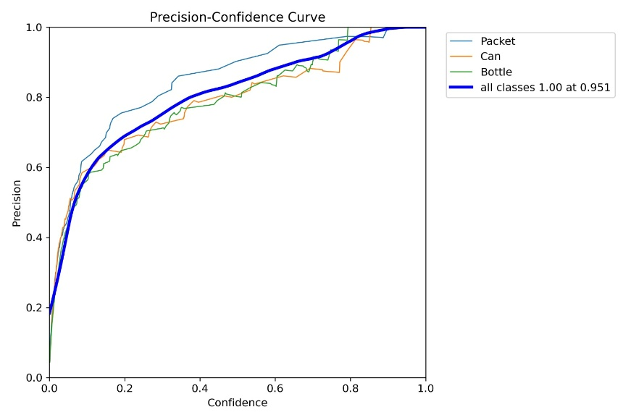
Fig. 15. Precision-Confidence Curve

Fig. 15. shows Precision Confidence curves of the Packet category, Can category and the overall model performance. The curves show that the accuracy is clearly better with higher confidence threshold, meaning that higher confidence detection is taken into consideration, which makes the model more reliable. Among the individual classes, Packet category has a higher precision at most confidence levels indicating consistent and confident detection of advertisement scenes. The Bottle and Can categories demonstrate a slow increase in accuracy, which has small fluctuations due to changes in the appearance of objects, reflections, and the intricacy of the background. It is worth noting that the performance sum of all the classes will be carried out to a precision of 1.00 with the confidence level of about 0.951 as indicated in Fig. 15. The pattern proves that the suggested detection system has close to perfect accuracy at increased certainty, indicating that it is suitable at appropriate levels of visibility and prominence detection of commodities in food and cosmetic advertisements.

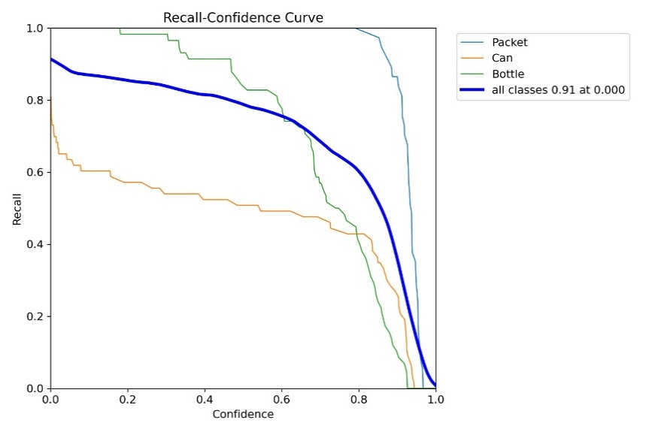
Fig. 16. Recall-Confidence Curve

Fig. 16. shows Recall-Confidence curves of the Packet, Can and Bottle classes and the overall recall quality of all the classes. The diagram shows the decreasing levels of recall as the level of confidence rises, the trade-off between identifying more objects and having high predictability. Packet class has a high recall with a broad confidence range meaning that the majority of the packet is always detected even at the moderate confidence levels. Bottle category is highly recalled under low confidence but the recall tends to reduce distinctly with higher threshold which can be explained by the variability of visual elements, reflections, and partial obscurity that are inherent in the advertisement scenes. Conversely, the Can category shows relatively lower recall when compared to most levels of confidence, which illustrates the challenge of representing all the cases of similar-looking objects in a cylindrical shape. The bold curve that represents all classes has a maximum recall of about 0.91 at a confidence threshold nearer to zero, as seen in Fig. 16, and slowly drops with an increase in confidence. This observation proves that reduced confidence levels prefer broad coverage of objects whereas the increased levels prefer more reliable detection object which serves as a valuable knowledge in picking the operation point in the analysis of visibility of food and cosmetic advertisements.
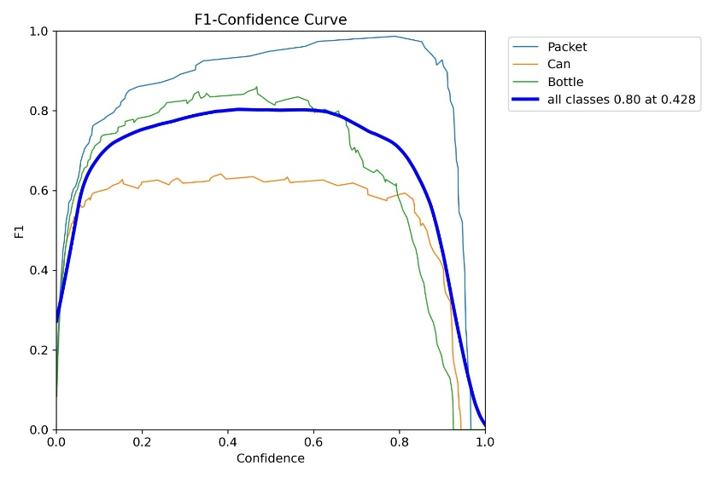
Fig. 17. F1 Confidence Curve
Fig. 17. shows the F1-Confidence curves of the Packet, Can, and Bottle type, and the combination of all the classes. The figure illustrates the changes of the balance between precision and recall as confidence threshold increases. The Packet category has the best and most consistent F1 scores over a large confidence interval, which demonstrates that the packet category has strong detection results in a variety of advertisement scenes. The Bottle class demonstrates competitive F1 values at the medium levels of confidence and a further decline in this case at higher levels probably because of changes in shape, reflections, and partial occlusions. Comparatively, the Can category has lower F1 scores, which is indicative of difficulties in maintaining a consistent balance between accuracy and recollection of visual similar packaging types. Fig. 17. indicates that the bold curve of all classes has its maximum F1 score of an approximation of 0.80 at a confidence level of 0.428 and this could be said to be the best operating point of the proposed model. This discussion shows that there is an optimal trade-off based on moderate confidence levels and the framework is appropriate to determine reliably the visibility of products in food and cosmetic advertisements.

- Class-wise Performance Analysis

The analysis of the model performance indicated in response to individual food-related object classes is given. There is also visible variation in the detection accuracy of the various food categories, which is indicated by the measures of class-wise precision, recall, and F1-score. The analysis assists in pointing out food objects that consistently have a high detection accuracy, usually because of their distinctive shapes and high visual saliency, and also pointing out categories that will not be detected easily because of visual similarity, packaging similarity, dynamic display in advertisements, and partial occlusion.

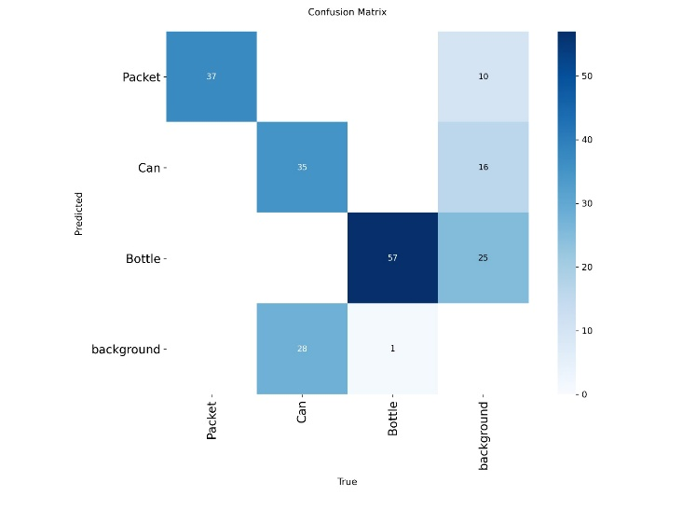
Fig. 18. Confusion Matrix

The confusion matrix of the YOLOv8-based object detection model as shown in Fig. 18. indicates the performance of the classifier in terms of the classification levels of the classes Packet, Can, Bottle and background. The diagonal items constitute correct predictions whereby the model scores high recognition of Bottle (57 instances), and then Packet (37) and Can (35) meaning that they learn to identify unique visual features of these product types. There are mostly misclassifications between product and background categories, background regions are wrongly classified as Bottle (25) or Can (16) which mirrors the visual complexity and clutter that is normally provided in an advertisement scene. Moreover, there are Can cases that are confounded as background (28), which is an indication of difficulties in identifying small objects or the ones with less saliency during different illumination and occlusion levels. In general, the confusion matrix shows a good performance in classes, with the greater accuracy of seen visually than those not seen visually, such as the bottles, and also indicates the possible area of improvement in terms of avoiding the background-related false positive cases. This discussion validates the usefulness of the model given to evaluate product visibility and the importance of better discrimination between fore ground products and complicated backgrounds in food and cosmetic advertisements in the real world.

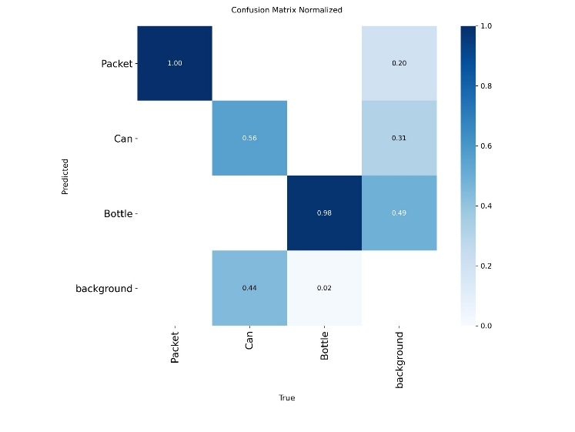
Fig. 19. Normalized Confusion Matrix
Fig. 19. shows the normalized version of the confusion matrix of the proposed YOLOv8-based detection framework, providing the view of the prediction performance in terms of the proportion of the classes to the Packet, Can, Bottle, and background classes. The diagonal values show good normalized accuracy of Packet (1.00) and Bottle (0.98), showing that these are product types that can be recognized by the model in a very consistent and reliable way. The Can category is moderately performing (0.56) with a rather more confusion indicating the differences in the shapes, size, and visual resemblance to the background contents in the advertisement scenes. Background misclassification is also a prominent issue, with a high percentage of background areas being classified as Bottle (0.49) and Can (0.31) pointing to the effect of a cluttered scene and text-filled images typical of food and cosmetics advertisements. On the other hand, the number of Bottle cases that are falsely identified as a background is a very small percentage (0.02) which also supports the strength of bottle detectors as the objects have a characteristic structure. In general, the normalized confusion matrix shows that the model has a great discriminative capacity concerning high-profile product categories as well as points to the areas in which improved background suppression and contextual modelling may increase the visibility analysis accuracy.

- Result and Visual Analysis
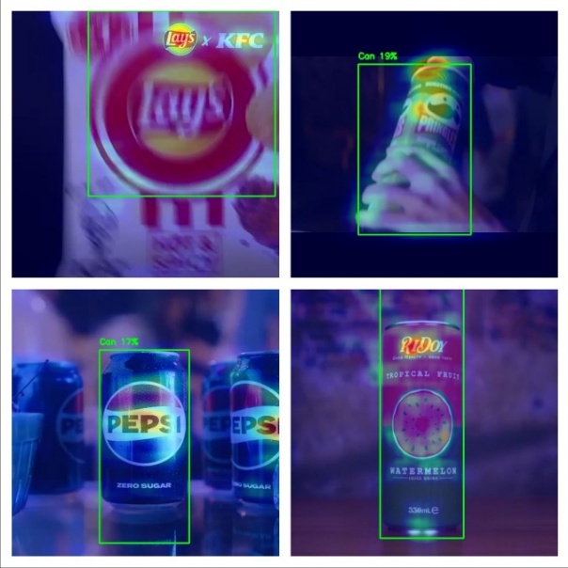
Fig. 20. Outputs for food Advertisement

In Fig. 20. the results of deep learning framework as applied to food and beverage ads are displayed in a more narrative form. The advertised products like snack packets and cans of soda are clearly shown just below a YOLO object detection model. The boxes surrounding those packets and cans are drawn in green where their confidence scores are entered at times. The heatmaps overlaid on top of the video indicate areas with high visual attention that lie mainly on product faces and brand-related regions which is clear indication that advertising aligns well with human visual perception. There is also OCR which is employed for extracting textual details for example brand names and product description from detected patches so it further enhances ad visibility assessment. By taking into account saliency prediction, object detection, as well as OCR, it can be observed that product's attention can be studied comprehensively in case of animated advertisement sequences even under difficult circumstances such as motion blur, various illumination levels as well as cluttered backgrounds. These findings demonstrate reliability of developed automated system for assessing food advertisement broadcast prominence.

- Conclusion

This study presented a deep learning–based framework for cosmetic product detection and classification using a YOLO architecture, aimed at addressing the challenges of accurately identifying visually diverse cosmetic items in complex visual environments. By leveraging end-to-end object detection, the proposed approach effectively learns discriminative spatial and semantic features across multiple cosmetic categories. Quantitative evaluation using precision, recall, F1-score, and mean Average Precision (mAP) demonstrates strong overall performance, confirming the robustness and reliability of the model in multi-class detection scenarios. The experimental results indicate that the model performs exceptionally well for visually distinctive categories such as lipstick and jar, which exhibit consistent shape and texture characteristics. In contrast, comparatively lower performance is observed for visually similar and structurally ambiguous categories such as pump and generic cosmetic products, highlighting the inherent challenges posed by inter-class similarity and dataset imbalance. Qualitative analysis further validates the quantitative findings, showing accurate object localization and classification under varying object scales, orientations, and background conditions, thereby demonstrating the practical applicability of the proposed method. Overall, the findings suggest that the proposed YOLO-based framework provides an efficient and scalable solution for automated cosmetic product recognition. The approach shows strong potential for deployment in real-world applications such as retail shelf analysis, product cataloging, advertisement content analysis, and intelligent visual inspection systems, establishing a solid foundation for further research and development in cosmetic product analysis.

references
- M. L. Ali and Z. Zhang, “The YOLO framework: A comprehensive review of evolution, applications, and benchmarks in object detection,” Computers, vol. 13, no. 12, p. 336, 2024.
- A. M. Hassan, R. K. Singh, and P. Kumar, “Performance analysis of deep learning-based object detection algorithms on the COCO benchmark,” Journal of Engineering and Applied Science, vol. 71, no. 76, pp. 1–15, 2024.
- S. Kang, Z. Hu, L. Liu, K. Zhang, and Z. Cao, “Object detection YOLO algorithms and their industrial applications: Overview and comparative analysis,” Electronics, vol. 14, no. 6, p. 1104, 2025.
- J. Novak, M. Petrovic, and A. Kovac, “Advancements in small-object detection (2023–2025): Approaches, datasets, benchmarks, and applications,” Applied Sciences, vol. 15, no. 22, p. 11882, 2025.
- D. Abhayankar, S. Tanwani, and D. K. Sharma, “Exploring object detection algorithms and implementation of YOLOv7 and YOLOv8-based models,” Int. J. Intelligent Systems and Applications in Engineering, vol. 12, no. 3, pp. 877–886, 2024.
- R. Mehta, P. Shah, and A. Kulkarni, “Comparative analysis of deep learning models for waste segregation using YOLOv8 and EfficientDet,” Multimedia Tools and Applications, vol. 84, pp. 35941–35964, 2025.
- Y. Li, H. Zhou, and J. Wang, “Leather defect detection based on an improved YOLOv8 model,” Applied Sciences, vol. 14, no. 24, p. 11566, 2024.
- A. Rahman and S. Putra, “Object detection using YOLOv8: A systematic review,” Sistemasi: Jurnal Sistem Informasi, vol. 14, no. 1, pp. 45–60, 2025.
- B. Inan, I. A. Ozkan, and N. Dogan, “Deep learning-based skin disease detection: Performance analysis of YOLOv8 and YOLOv11 models,” Int. J. Applied Methods in Electronics and Computers, vol. 13, no. 4, pp. 121–130, 2025.
- N. A. Dalawai, P. B. Prathamraj, B. S. Dayananda, A. P. Joythi, and R. Suresh, “Real-time skin disease detection and classification using YOLOv8 object detection,” Int. J. Multidisciplinary Research and Analysis, vol. 7, no. 12, pp. 210–218, 2024.
- L. Chen, W. Ouyang, X. Wang, and J. Zhou, “Development and challenges of object detection: A survey,” Neurocomputing, vol. 598, p. 128102, 2024.
- A. Wang, H. Chen, L. Liu, Z. Lin, J. Han, and G. Ding, “YOLOv10: Real-time end-to-end object detection,” arXiv preprint, arXiv:2405.14458, 2024.
- R. Khanam and M. Hussain, “YOLOv11: An overview of key architectural enhancements,” arXiv preprint, arXiv:2410.17725, 2024.
- A. Chandrashekhar, B. Satyanarayana, R. R. Gorrepati, and S. Rao, “An efficient YOLO-based framework for detecting extremely small-scale objects,” Scientific Reports, vol. 16, p. 2062, 2026.
- G. Jocher, A. Chaurasia, and J. Qiu, “Ultralytics YOLOv8: State-of-the-art real-time object detection,” Ultralytics White Paper, 2023.
- T.-Y. Lin, M. Maire, S. Belongie, et al., “Microsoft COCO: Common objects in context,” in Proc. Eur. Conf. Computer Vision (ECCV), 2014, pp. 740–755.
- X. Zhou, D. Wang, and P. Krähenbühl, “Objects as points,” arXiv preprint, arXiv:1904.07850, 2019.
- L. Liu, W. Ouyang, X. Wang, et al., “Deep learning for generic object detection: A survey,” Int. J. Computer Vision, vol. 128, pp. 261–318, 2020.
- K. He, X. Zhang, S. Ren, and J. Sun, “Deep residual learning for image recognition,” in Proc. IEEE Conf. Computer Vision and Pattern Recognition (CVPR), 2016, pp. 770–778.
- T.-Y. Lin, P. Goyal, R. Girshick, K. He, and P. Dollár, “Focal loss for dense object detection,” in Proc. IEEE Int. Conf. Computer Vision (ICCV), 2017, pp. 2980–2981.

Don’t use this one….

